 

Project Title: Lease Management

College Name: SREE SAKTHI ENGINEERING COLLEGE:7136

Department of Computer Science and Engineering

## Team Leader:

Name: Varun M Reg No: 713621104044

## Team Members:

Name: Aanandhkumar R V Reg No: 713621104002

Name: Vishnu priya S Reg No: 713621104323

Registered Email Id:aanandhkumarak@gmail.com

 

# Project Name: Lease Management

### Project overview:

This initiative focuses on developing a Lease Management System in collaboration with Salesforce.com to create an application tailored for property management. The LMS application encompasses all essential features required to oversee various operations within the real estate industry, adhering to established best practices. Offered as a Software as a Service (SaaS), it is accessible online from any device. The technological framework is backed by Salesforce.com (www.salesforce.com), ensuring secure data storage and the implementation of necessary security measures. The objective of this study was to design and implement a cloud-based Lease Management System that provides detailed and summarized insights into critical areas, aiding LMS administrators in their planning and decision-making efforts. The system is available anytime and anywhere, as data is stored remotely and accessible via the Internet. This project emphasizes user-friendliness, usability, performance, and security, demonstrating its robustness. Consequently, other property owners may be inclined to adopt this system for enhanced information management, improved decision-making, and the maintenance of strong client relationships, as the LMS facilitates the management of real estate operations.

### Objective:

The main objective of a leave management system is to help businesses manage employee absences in a fair and accurate way. This can be achieved by:

**Business Target:**

Asset leasing is a widely adopted practice among businesses of all types and sizes. This method presents numerous benefits, including greater purchasing power, lower maintenance costs (assuming the lessee does not bear maintenance responsibilities), and more effective cash flow management.

 

**Particular goal:**

Leasing assets has emerged as a common tactic for businesses in diverse sectors and of varying sizes. This method presents several benefits, including greater purchasing power, decreased maintenance costs (if the lessee is not liable for maintenance), and enhanced cash flow management.

**Enhancing the efficiency of the leave application process.**

#### A leave management system acts as a link between employees and employers, improving the effectiveness of the leave application and approval process.

#### Facilitating clarity and management.

It is essential for employees to have an easy-to-follow system for applying for leave, accessing their leave information, and tracking the status of their leave applications.

**Streamlining processes by removing paper-based tasks**

#### The implementation of leave management systems enhances the efficiency of leave request handling, significantly lowering the necessity for manual processing and related paperwork.

#### Fulfilling legal requirements.

#### Meeting state-imposed legal obligations is an essential element of an effective leave management system.

 

**Salesforce Key Features and Concepts Utilized**

**Organization:**

Establishing a detailed sales plan and assigning roles to team members.

**Sales Tactics:**

Creating and executing strategies that are clear and actionable.

**Customer Engagement:**

Nurturing valuable relationships with key clients.

**Sales Data Analysis:**

Reviewing historical campaign data to develop improved and more efficient campaigns.

**Training:**

Guiding sales representatives to boost their performance and realize their maximum potential.

**Forecasting:**

Preparing for future needs to ensure appropriate inventory and staffing levels, along with compensation planning.

 

# Detailed steps to solution design

### Step 1: Creating Developer Account and Activation

To create a developer organization within Salesforce, start by activating your account.

Click on the "Verify Account" link, then set a password and provide an answer to a security question.

After clicking "Change Password," you will be redirected to the Salesforce setup page.

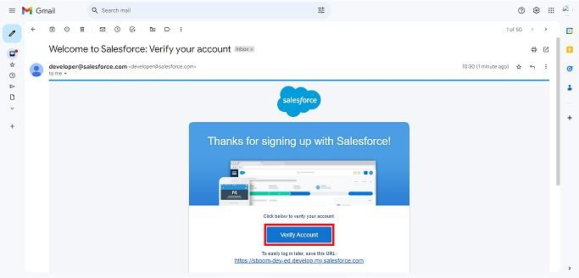

 

### Step 2: Create of objects

Create Property Object, tenant object, lease object and payment object.

From the setup page >> Click on Object Manager >>Click on Create >> Click on Custom Object

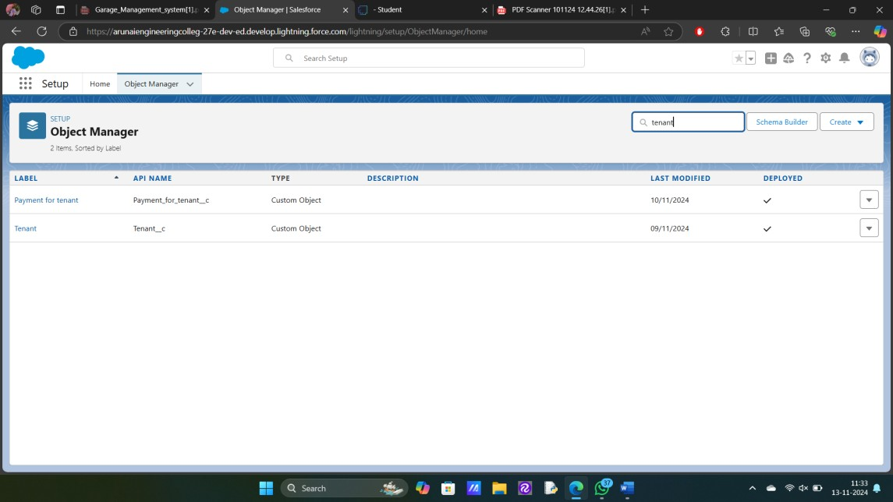

Enter the label name for the appropriate object. Then enter the Plural label name.

Enter Record Name Label and Format Record Name and Data Type.

### Step 3: Creating a Custom Tab

A tab is like a user interface that is used to build records for objects and to view the records in the objects.

 

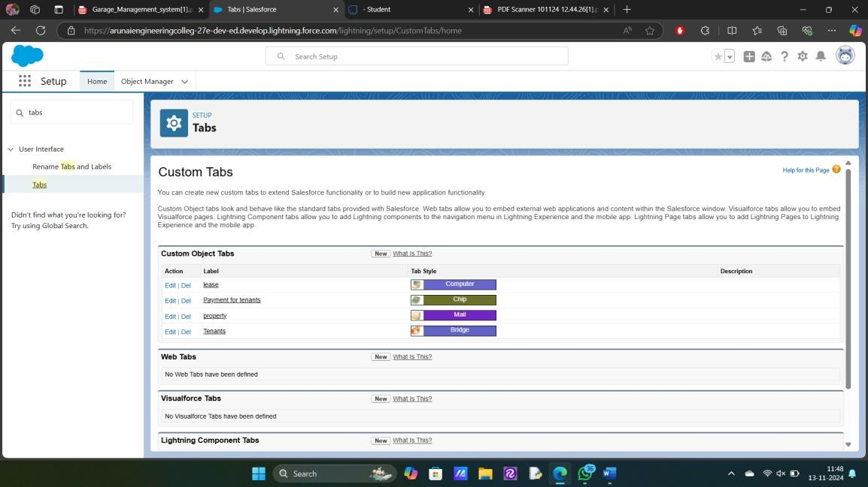

### Step 4: Create a Lightning App

An app is a collection of items that work together to serve a particular function.

### To create a Tab:( Property)

* Goto set up page. Search tabs on quick find bar click new under custom tab.
* The first step is to select object property and tab style.
* Make sure that the Append tab to users' existing personal customizations is checked. Click save

 

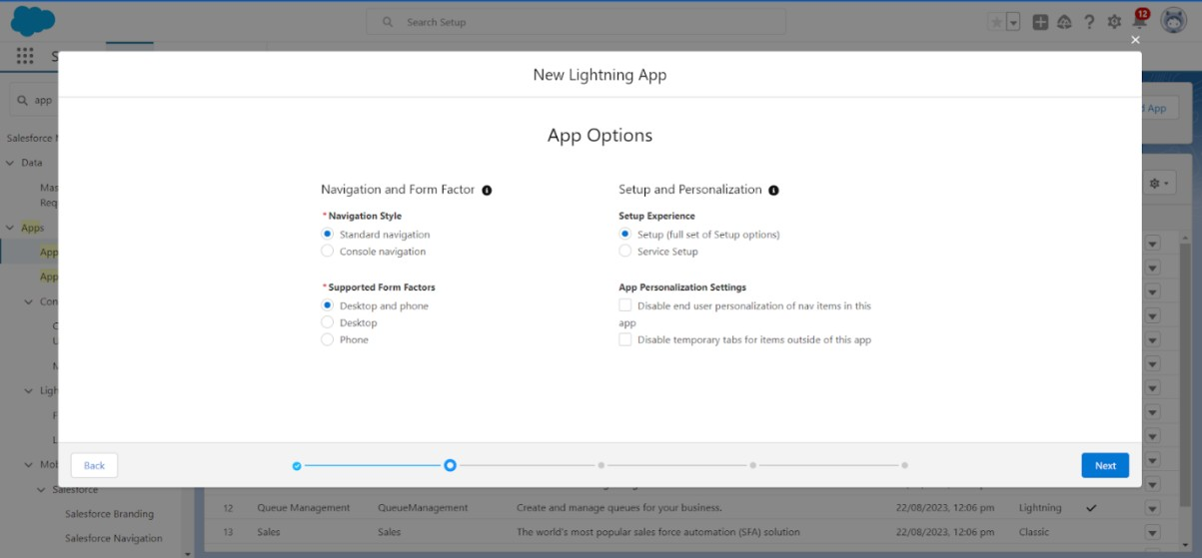

Create a lightning app with an App Name of “Lease Management”

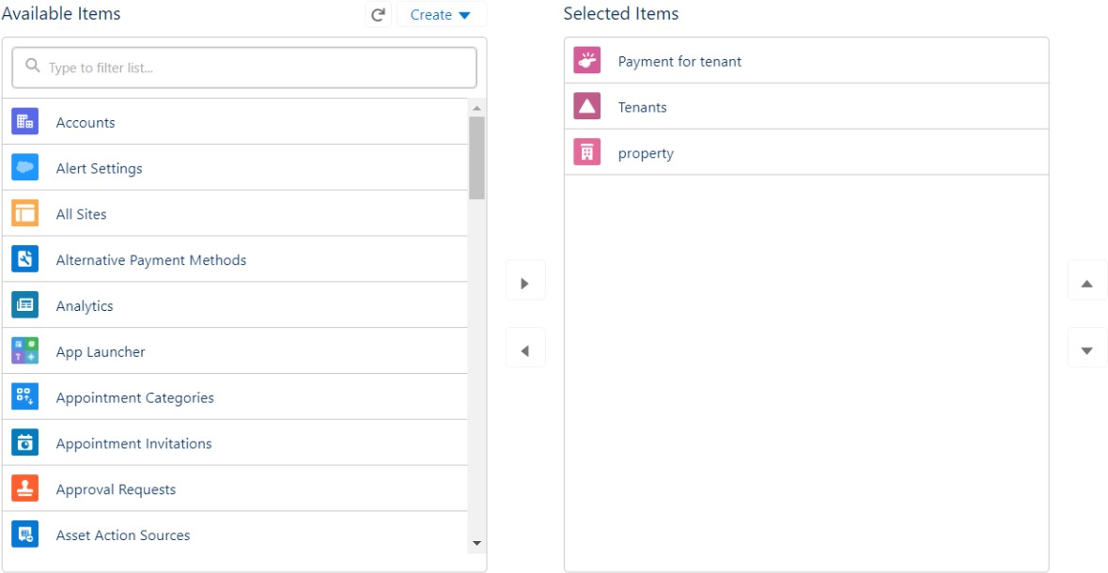

### Step 5: Field Creation

Creation of fields for the property object, Tenant object, Lease object, Payment for tenant object, Lookup object.

 

Go to setup then click on Object Manager to type object name(Tenant) in search bar and click on the object.

* Field Label : Email
* Field Name : gets auto generated
* Click on required check box
* Click on Next >> Next >> Save and new.
* Field Label : start date
* Field Name : gets auto generated
* Click on Next >> Next >> Save and new.

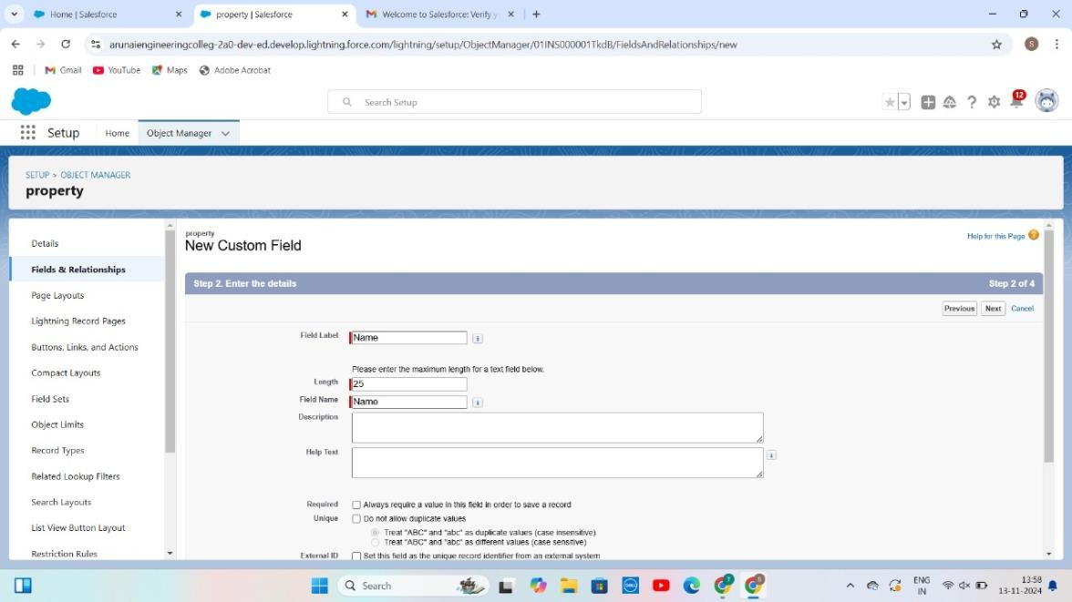

 

### Step 6: Validation rules

To create a validation rule to an Lease Object.

Go to the setup page click on object manager from drop down click edit for Lease object**.**

Click on the validation rule.click new Rule name= lease_end_date

* + Insert the Error Condition Formula as : End_date c > start_date c

Enter the Error Message as “Your End date must be greater than start date”, select the Error location as Field and select the field as “start date”, and click Save.

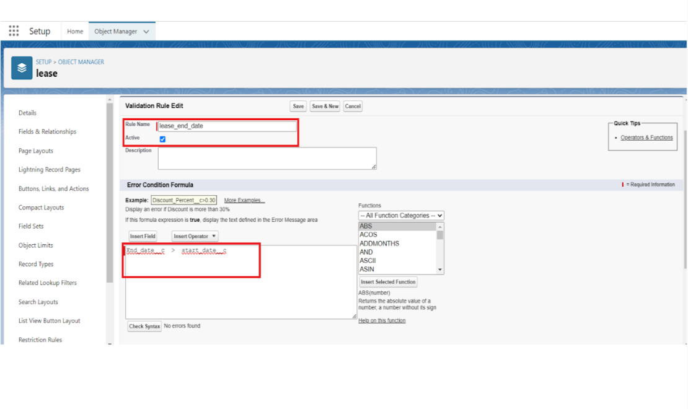

 

**Step 7: Email templates**

### Create Email Template For Tenant Leaving

* + Go to setup in quick find box enter email template, click on classic Email template.
  + Then click on new email template choose text
  + Email template name: tenant leaving
  + Template unique name: Auto populated
  + Subject: request for approve the leave
  + Email body:

Dear {!Tenant c.CreatedBy}, Please approve my leave.

* + Save.

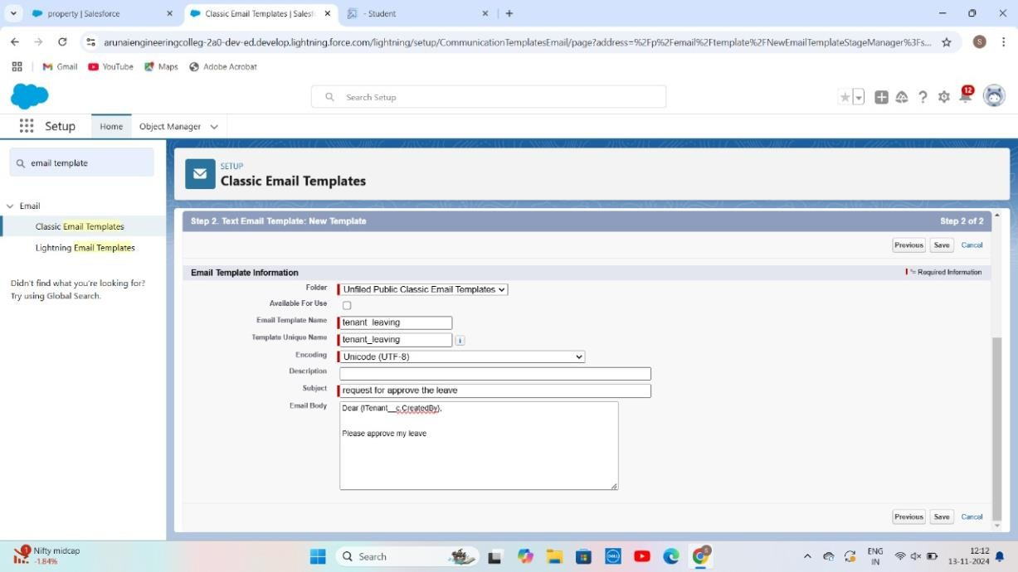

 

### Create Email Template For Leave Approved

* + Go to setup in quick find box enter email template >> click on classic Email Template.
  + Click on >> New Email Template===>Choose text
  + Email Template Name=Leave approved
  + Template Unique Name : Auto populated
  + Subject =Leave approved
  + Email body :
  + dear{!Tenant c.Name},

I hope this message finds you well. I am writing to inform you that I have received your email confirming the approval of my leave request. I would like to express my gratitude for considering and approving my time off.

Your leave is approved. You can leave now.

* + Save

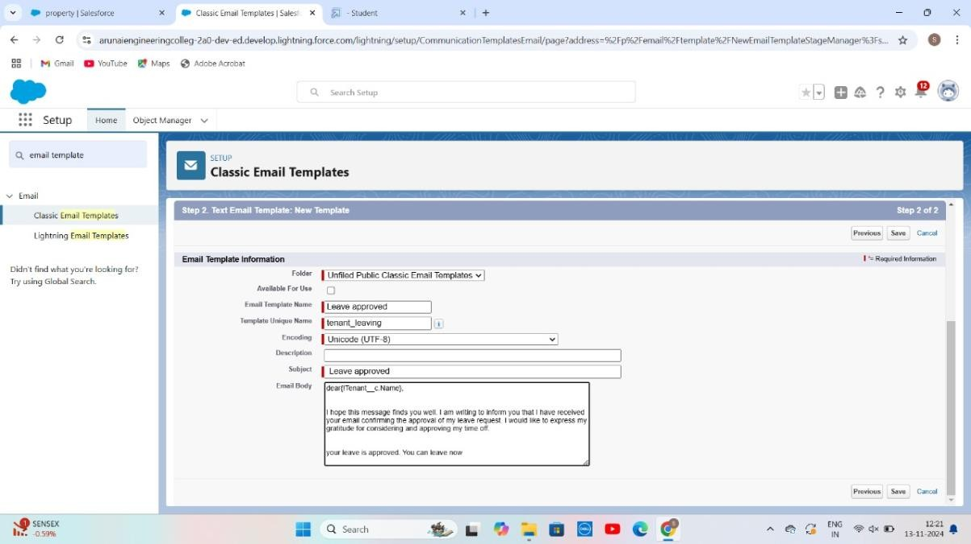

 

### Create Email Template For rejection for leave

* + Go to setup in quick find box enter email template >> click on classic Email Template.
  + Click on >>New Email Template===>Choose text
  + Email Template Name=Leave rejected
  + Subject : ” Leave rejected”
  + Email body :
  + Dear {!Tenant c.Name},
  + I hope this email finds you well. Your contract has not ended. So we can't approve your leave
  + your leave has rejected
  + Saved

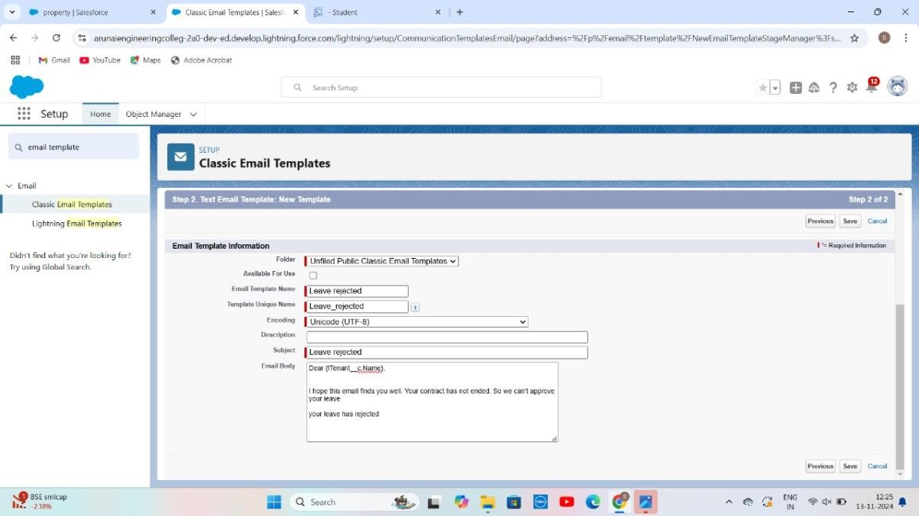

 

## Step 8:Approval Process

### What Is Approval Process In Salesforce?

The Approval Process is an automated process that an org uses to approve records in Salesforce. For example, When In the organization, someone is not able to decide a particular thing then he can ask someone else for

approval. So, for such frequent cases or situations, one can define the approval process. So, Users can take benefit of such an approval process whenever

needed.

There are 4 actions,

1. Initial Submission Actions
2. Final Approval Actions
3. Final Rejection Actions
4. Recall Actions.

An approval process consists of finalizing the basic properties of the approval process (as shown in the below image), approval steps, and actions to be

executed.

### Create Approval Process For check for vacant.

* + Go to setup >> Approval Processes in quick find bar>>click on it.
  + Manage Approval Process For >> “Tenant” from the drop down.
  + Click on “Create New Approval Process” >> Use standard setup wizard
  + Process Name “check for vacant” >> Click Next.
  + Field “Tenant:status” >> Operator : Not equals , Value >> Click on the lookup filter icon and select “Leaving”.
  + 6.Click insert field,then click Next.

 

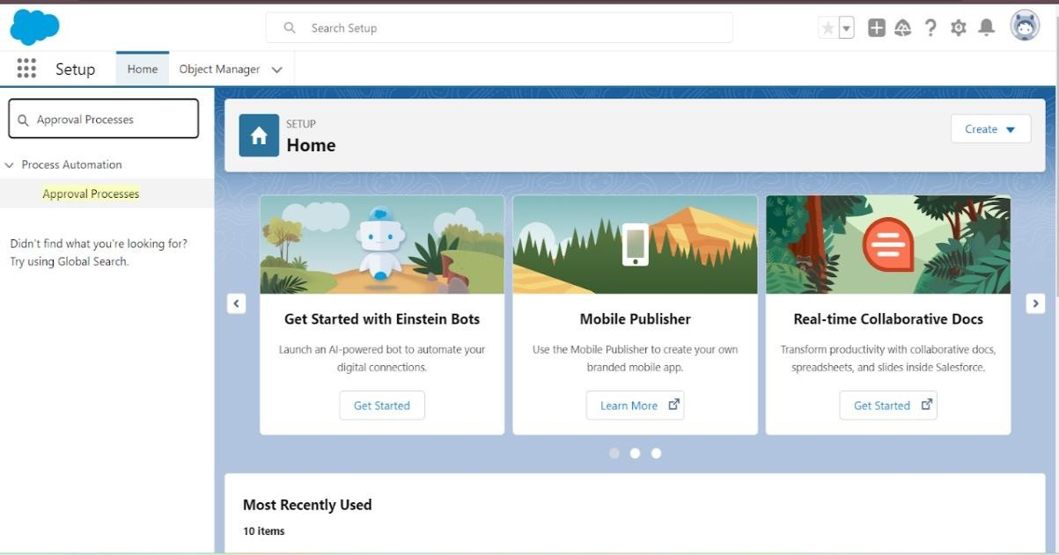

* Next Automated Approver determined by “None” from the drop down.
* Select the “Administrators ONLY can edit records during the approval process”. Then Next.

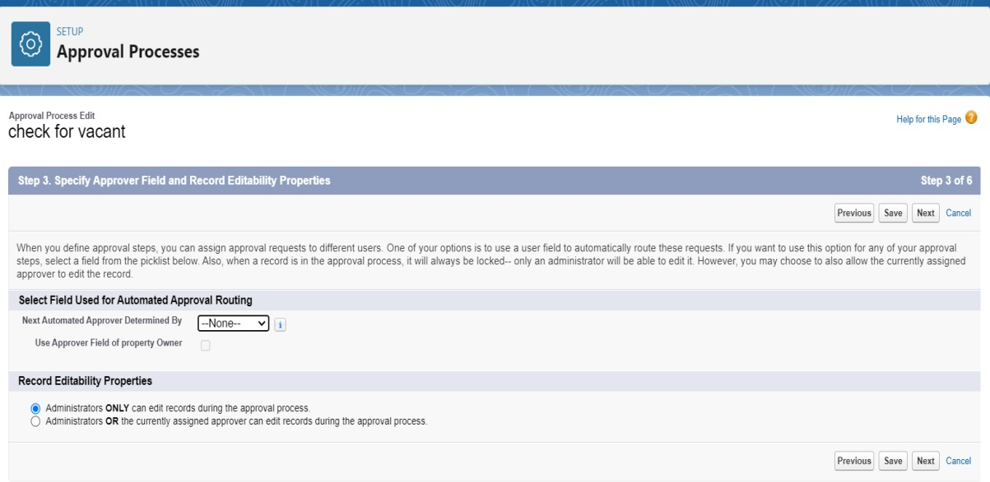

 

* Click on next leave the email template click on next
* Submitter type Search>>Owner, Allowed Submitters>>Property Owner. Then Next.
* Then click on Save.

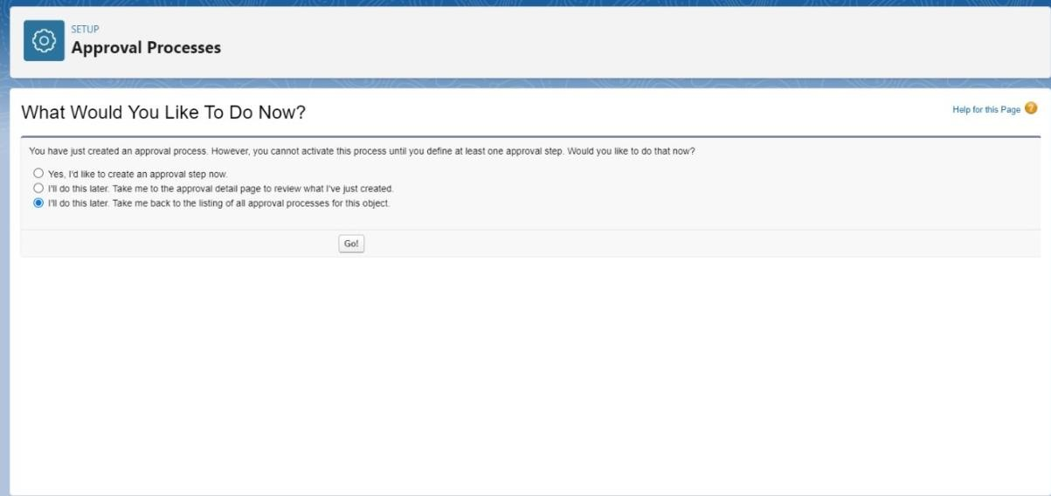

* Click on “i’ll do this later. Take me back to the listing of all approval process for this object”
* Click go.

### Initial Submission Action:

* + Under initial submission action click on add new and then select email alert.
  + Description: “please approve my leave”.
  + Unique name: auto populated.
  + Email template: tenant leaving.
  + Recipient type: Email field.

 

## Step 8: Flows

In Salesforce, a flow is a tool that automates complex business processes. Simply put, it collects data and then does something with that data. Flow Builder is the declarative interface used to build individual flows.

**Create Flow for monthly payment**

1. Go to setup then type Flow in quick find box Click on the Flow and Select the New Flow.
2. Select the record Triggered flow. Click on create.

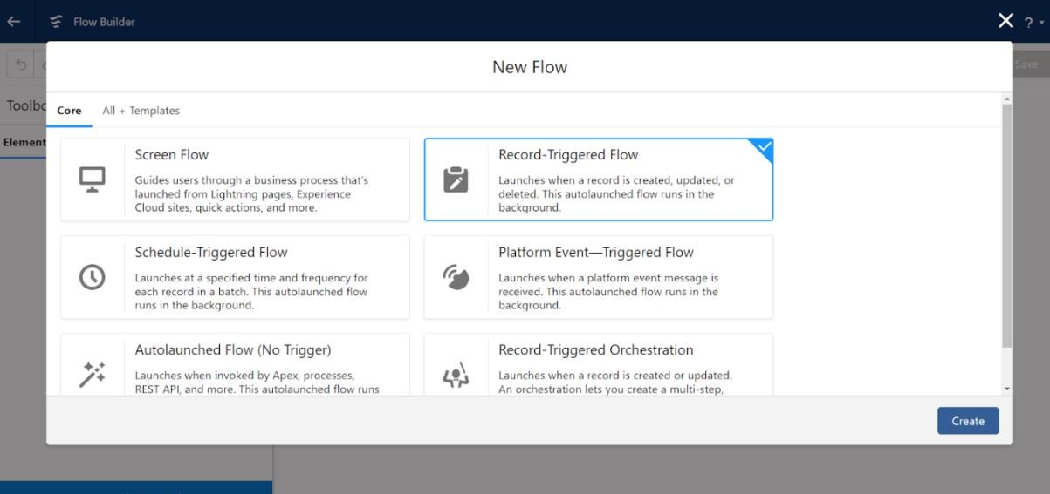

Click on: Every time a record is updated and meets the

condition requirements Click on: Actions and related records is done

 

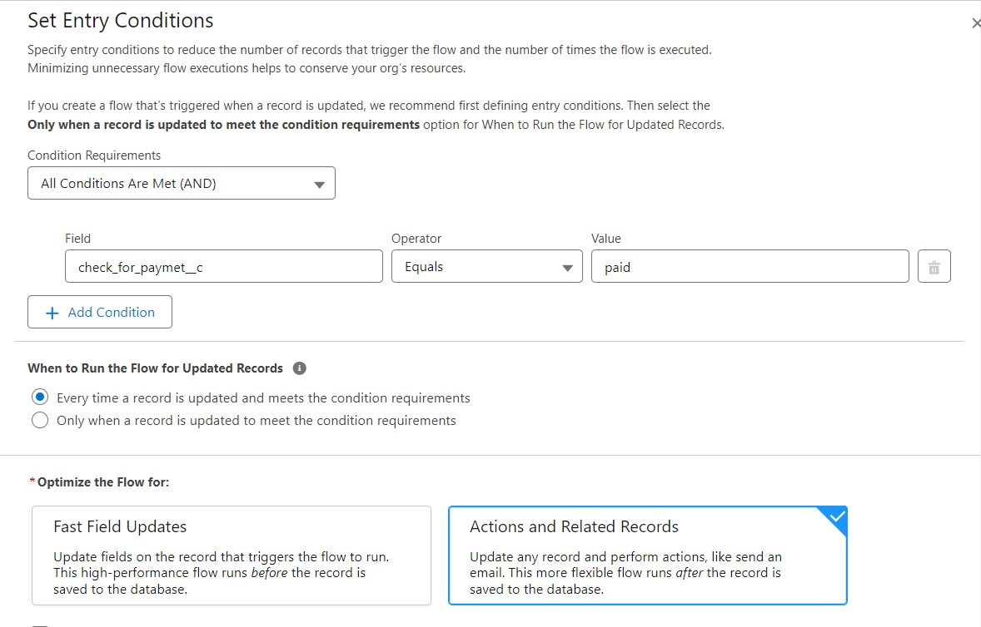

## Test and validation:

Testing and validation in lease management can involve a variety of activities, including:

**Lease validation services:**

Help property management companies ensure that lease agreements are legal and enforceable. These services can help identify issues and verify the terms and conditions of a lease.

### Test planning and execution:

This involves executing and monitoring validation tests

according to a test plan and design. It also includes verifying and validating the test results, and recording and reporting any issues or defects.

 

### Test objectives and criteria:

These should be defined clearly and explicitly before starting testing and validation. They should align with the project's goals, scope, specifications, and the needs and expectations of the stakeholders and users.

### Validation testing:

This is used to verify that the final product meets the

expectations and requirements of the customers and stakeholders. It usually happens after the product is fully developed and focuses on confirming that it works as intended in real-world scenarios.

# Conclusion:

# Lease financing is a strategic option for individuals who encounter challenges in securing funds through debt financing. It enables asset holders to lease their properties to businesses, fostering a positive relationship between the lessor and lessee. Our CRM-enhanced lease management system improves this process by helping users discover ideal locations for both residential and commercial applications. This initiative proves beneficial for residential clients as well as business owners.